Assigment No 15
1) Assume there is a table called Multicust, with
all of the same column definitions as Salespeople.
Write a command that inserts all salespeople with
more than one customer into this table.

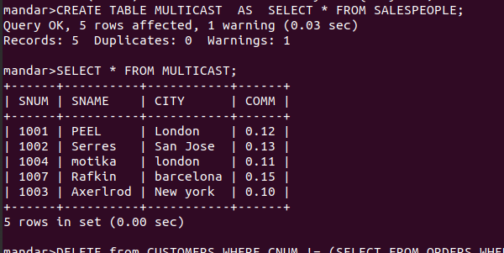

2) Write a command that deletes all customers with
no current orders.

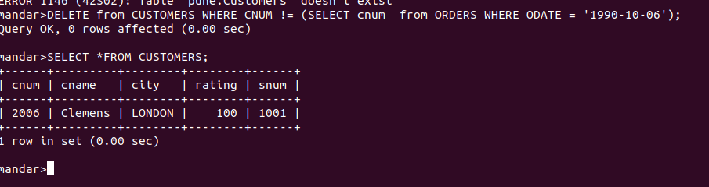
3) Write a command that increases by twenty
percent the commissions of all salespeople with
total orders above Rs. 3,000.

